How We Run IPMA
IPMA Governance consists of a Council of Delegates, an Executive Board, several Management Boards, working and project groups and a Secretariat. The Council and Board Members are from all over the world and reflect the Global nature of IPMA.
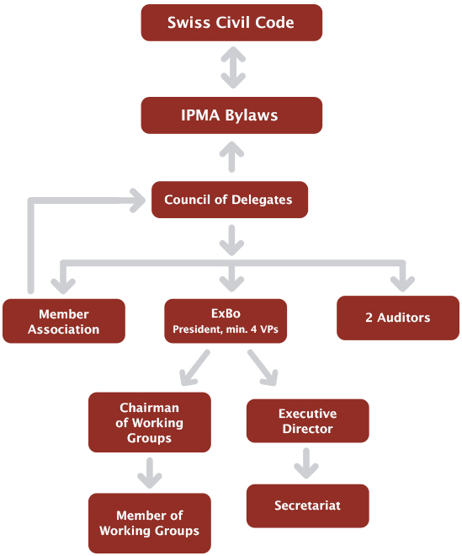

IPMA is member-driven, and volunteer-staffed. Aside from contracts for our Secretariat and the guidance of a professional manager, all boards and Member Associations are filled with practicing project or program managers.
With a geographically-distributed organization, we collaborate on an ongoing basis, and hold board and council meetings regularly around the World.
The governing philosophy of IPMA is to achieve agreement through effective communication and by consensus; and to avoid yes/no voting procedures as often as possible.

